# Atharv Arya

1BM18CS020

PROGRAM TITLE: TEMPERATURE SENSOR(LM35)

## Aim: DEMONSTRATE AND MAKE YOUR OWN TEMPERATURE SENSOR BY ARDUINO AND LM35 SENSOR

Hardware Required:

* Arduino Board
* Breadboard
* LM35 Temperature Sensor

Circuit Diagram:

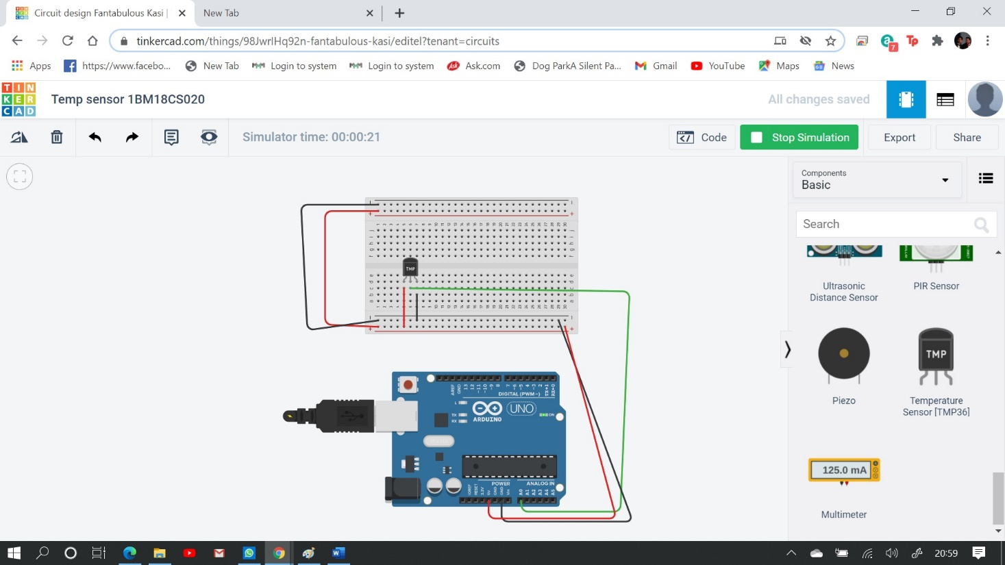

Write-Up:

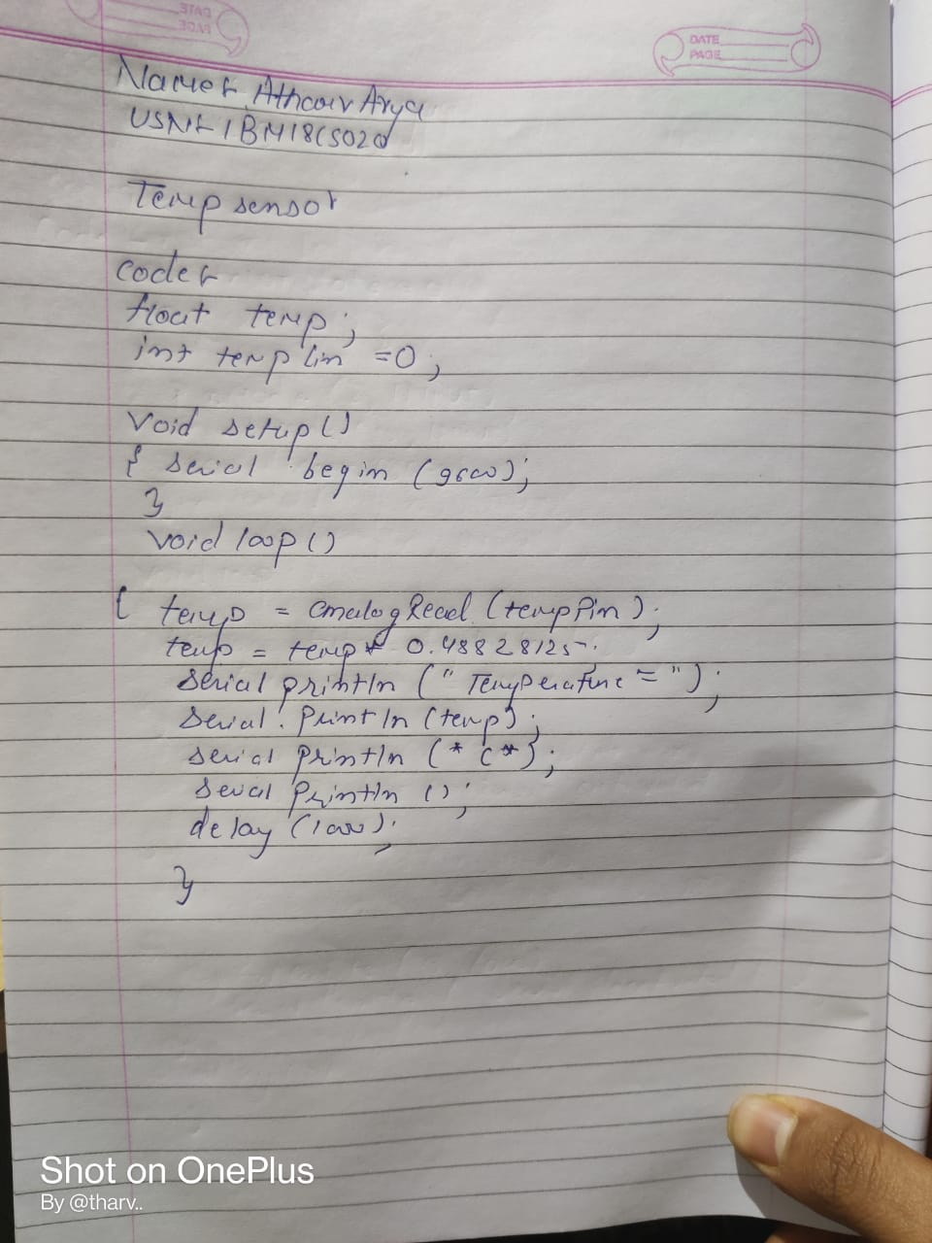

CODE:

float temp;

int tempPin = 0;

void setup()

{

Serial.begin(9600);

}

void loop()

{

temp = analogRead(tempPin); temp = temp * 0.48828125; Serial.println("TEMPERATURE = "); Serial.println(temp); Serial.println("*C"); Serial.println();

delay(1000);

}

## OUTPUT/OBSERVATION:

Temperature is being measured.